Lab 1 Aria

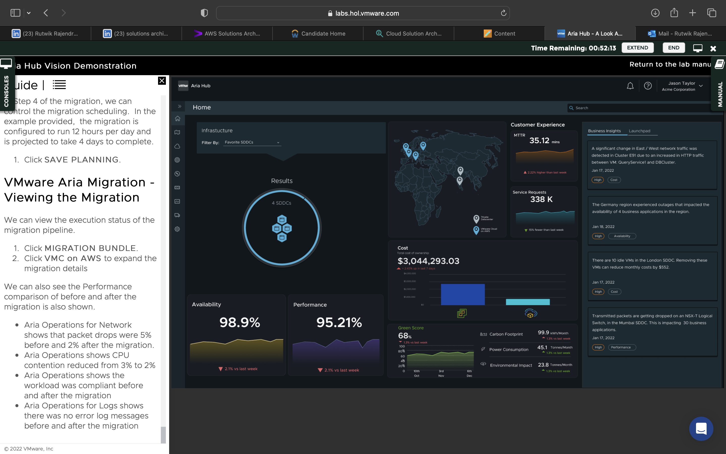

Learnt to view Business Insights of varying categories, to view the application view, viewed Key Metrics and Insights associated with Inventory Management, view the application availability metrics, application cost metrics, view the EC2 instance, the performance metrics of the EC2 instance, the costs for the instance, the delivery details, the secure configuration, learnt to view the Business Insights for the Inventory Management, view the VMware Aria Guardrails Policy Violation to see what is affecting the application across multiple security engines. We learnt to review the policies, security policy templates, remediate a violation of the policies.

We then switched to an admin view, viewed the graph view of the infrastructure, viewed the different environments, viewed an insight for high memory utilization, viewed performance metrics, viewed delivery information for the deployment, viewed the migration item scope, recalculated TCO, bundled and started the migration plans, and went through with it.